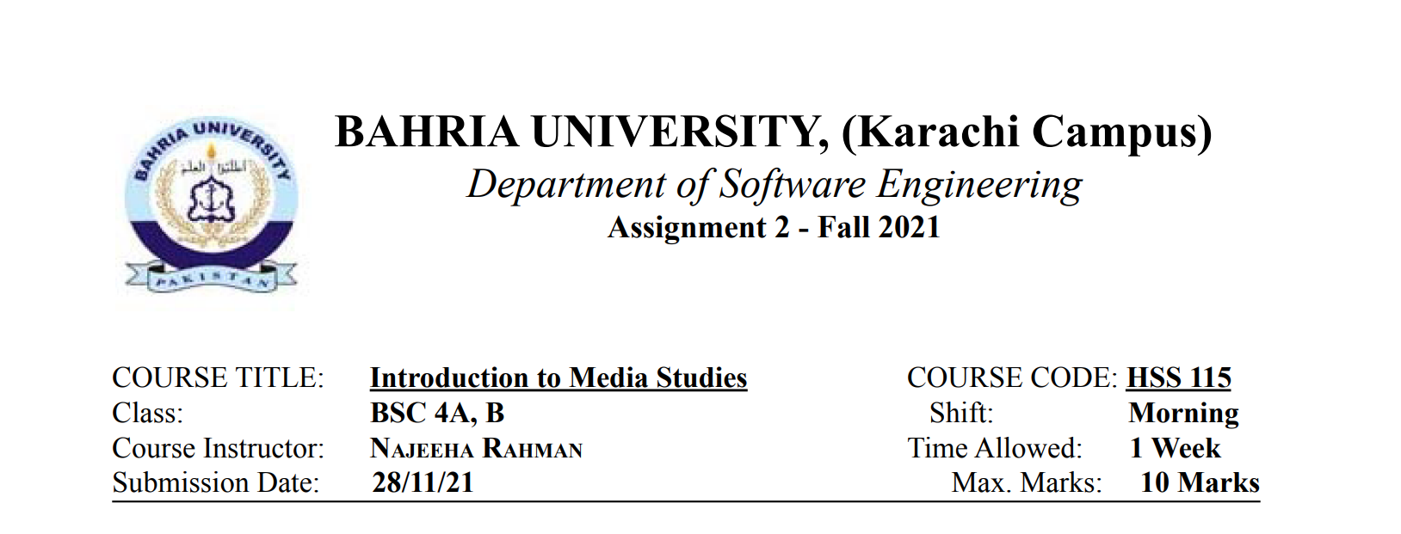

Name : **Muhammad Junaid Saleem Qadri** Reg. No: **70003**



**“ Importance of Time ”**

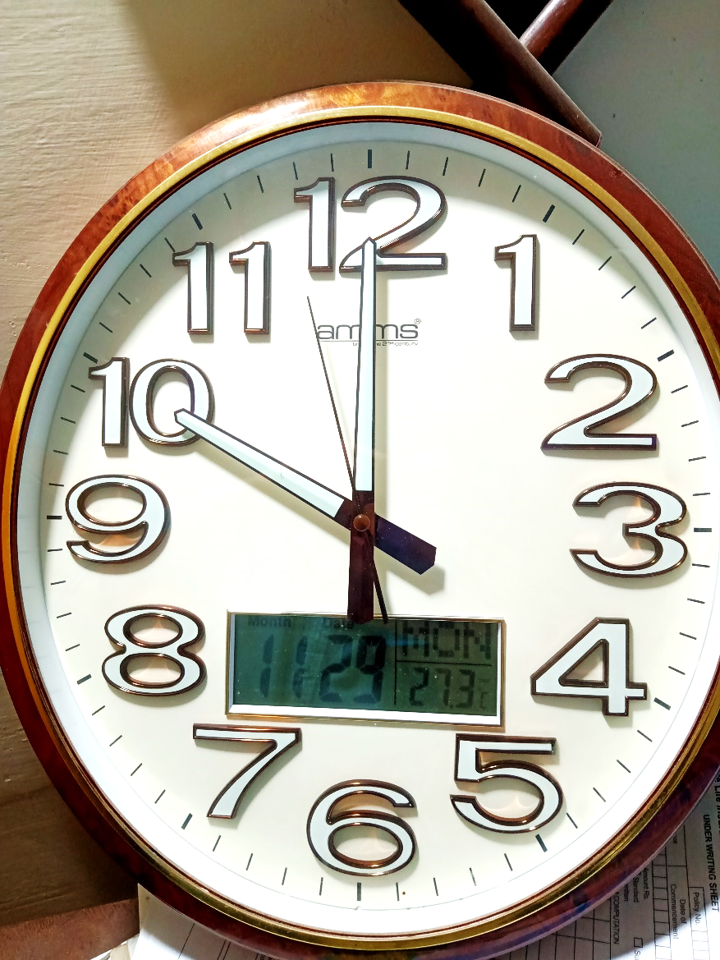**Introduction :**

The critical success factor for success in life is time management and time management will always remain the critical factor for the person to be successful in life.

For example, if a student does not study regularly he may face problems during the exam and as a result, his result will be affected. Therefore, the management of time is really important to become a successful person in life.

We have all heard the proverb “**Time and tide waits for none**” and this is the best-suited proverb as ‘**the tide does not wait for anyone**’ in the same manner time also does not wait for anyone. Instead, we should make time our opportunity and grab it as it is really precious and important for our life. Thus we have significant Importance of Time in our life.

“**Yesterday is gone. Tomorrow has not yet come. We have only today. Let us begin**.” (Mother Teresa)

**Why Time is Important ?**

**1. Punctuality:**

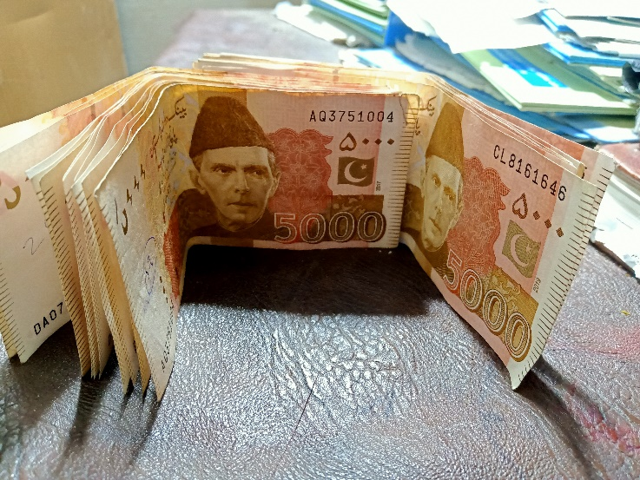If someone want to live a better life then he should be punctual in his life. The people who understand the importance of time is always punctual as is also successful in life. If a person is not punctual in his life then he would have to face many punishments and other consequences. Therefore one must understand the value of time and should be punctual in life.

**2. Time is invaluable:**

Time is much more valuable than money because we can earn money in any sphere of our life but we cannot earn the time back which has already been passed away by any means. The flow of time cannot be stopped and therefore we should use our time wisely.

**3. Courtesy:**

We should always be on time. If we do not respect our time it doesn’t mean that the other person is also not respecting the time. If we have some appointments, we should always be on time and should not waste the time of another person.

**4. Future is Unseen:**

Our future is unseen we all know that. Therefore, we should work hard and perform all our tasks on time in order to make our future bright because economic and financial situations of the country are fast-changing and therefore we should work hard and complete all are assigned tasks on time in order to avoid chaos.

**5. Time – The Best Medicine:**

Ovid says, “**Time is the best medicine”** and it is really true that time is the best medicine as it helps to heel us all our wounds’ feelings and broken hearts. Time helps to also forgive the person for his mistakes and hence said to be the best medicine.

“**Killing time is not a murder, it is a suicide**” suits to those who don’t know the value of time and also not respect the time as they are always involved in useless things, wasting time or doing nothing. People also give excuses like they do not have time for doing their works. It’s not the thing that they do not have time but they don’t know how to manage time. Everyone in the world has 24 hours a day. It depends upon them how they manage their golden 24 hours and how they set their priorities. If we manage our time in a proper and useful way no one can stop us from being a successful person in life.

**Conclusion :**

Time is really precious and important for all of us. Therefore, we should never waste time. Time is very important in our lives and plays a significant role. Our whole life revolves around time. We should respect the time and also understand the value of time because the time gone is never going to come back. It’s better to follow and respect time instead of regretting afterwards. Therefore, we should manage our time in a proper way and achieve our goals in life and become a successful person.

**When a Bird is alive….it eats ants.**

**When the bird is dead…ants eat the bird.**

**And circumstances can change at any time.**

**Don’t devalue or hurt anyone in life.**

**You may be powerful today. But remember,**

**Time is more powerful than you.**

**One tree makes a million match sticks…**

**Only one matchstick is needed to burn a**

**Million trees.**